The Placement Details

Job title of placement: Intern

Nature of the work/job description:
Balkan Diskurs Articles. Interns will be responsible for writing articles for PCRC’s Balkan Diskurs online platform throughout their internship. Balkan Diskurs (www.balkandiskurs.com) is a regional multimedia network of writers, bloggers, multimedia artists, and activists who came together in response to the lack of objective, relevant, invigorating, independent regional media.
Our platform has no restriction on theme, but we are ultimately dedicated to challenging stereotypes and providing viewpoints that cannot be found in other media. As such, some of our regular topics include transitional justice, inequality, and human rights. We aim to present these topics and make our region more understandable for both local and international audiences.
Sometimes topics will be assigned, however, interns are encouraged to propose their own ideas related to their academic and personal backgrounds and interests. We work with our interns to set up interviews and help guide them during the publishing process.
Meetings and Seminars. PCRC will organize meetings and seminars that are relevant to PCRC and/or your research. Interns will be designated with various tasks during meetings, which includes writing summaries, creating posts for social media and taking photographs. Interns will also be instructed to conduct background research about the organizations and people they will be meeting with and to draft questions to ask before any site visit.

PCRC Projects, Events, and Other Tasks. Event planning, grant writing, interview transcription, editing, communications and outreach, social media content creation and management, graphic design, research, and project development tasks are often delegated throughout the internship. Some individual tasks are assigned and some tasks are a team effort. We ask that you keep an open mind and remain flexible!

Approximate number of hours per week: 35 - 40

Basic structure: Interns will work in the PCRC office 4 days per week with scheduled site visits, interviews, and other activities planned for out-of-office days.

Internship timeframes: PCRC accepts interns based on the schedule detailed below.

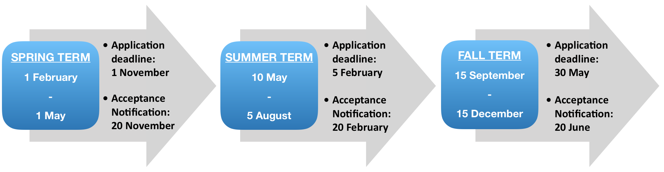

Skills
Which key skills are required? Strong writing skills, research experience, and creativity.
Required languages: English
Desirable languages: Bosnian/Croatian/Serbian, French, Italian, Spanish, Arabic, German, and Turkish are always useful, but any second language is welcomed.
Desirable skill sets: Photography, journalism, filmmaking, grant writing, website management, graphic design, editing, project development, translation, transcription, fundraising, monitoring and evaluation, policy research and analysis, and social media management.
Additional notes and comments: The PCRC internship is designed to allow our interns to explore their unique interests while creatively contributing to our overall mission. We are looking for self-motivated and passionate people who can bring positive energy to the PCRC team.

Frequently Asked Questions
Is accommodation provided? Interns are responsible for setting up their own accommodation. If accepted, we will provide you with information about where to find housing.
How much does housing typically cost? From May – September, housing + utilities can range from 175 – 350 EUR (200 – 400 USD) per month. In the winter months, the range is 200 – 400 EUR (225 – 450 USD) per month. The variation can depend on housing location and whether or not you have a roommate.
How much does the average meal cost? When eating out, a typical lunch ranges from 3 – 5 EUR and the average dinner can range from 5 – 10 EUR. We recommend a budget of 125 – 200 EUR per month.
Does PCRC provide any equipment? Internet access and office space is provided.
Will there be are any other costs to the intern? Interns are given the opportunity to participate in optional field visits to locations outside of Sarajevo. PCRC typically covers costs for project-related activities, however, some costs such as accommodation, travel and food may be required to participate in special events. For these types of events, participation is optional.
Is PCRC able to provide any financial assistance to support internship participation? No. The intern must be able to cover his/her own living costs.
What are the visa requirements? For most countries, visitors do not need to obtain a visa before their arrival in Bosnia and are allowed to stay in country for a total of 90 out of 180 consecutive days without one. Please note that the 180 days starts from the date of your entry, and only the days that you are physically in Bosnia are counted towards your 90-day total within this timeframe. This means that if you travel outside of Bosnia, the count stops until you re-enter the country. Visa regulations have recently become much more strict, so if you exceed your 90 day limit you risk being stopped from exiting the country until paperwork has been filed and a fine has been paid. Getting caught will additionally result in a 1-year ban from the country.

